C.N.G.K. Black Belt Requirements

Black belt grading protocol:
Students wishing to be graded to Black Belt with Canadian Naha-te Goju Karate must be sponsored by a Head Sensei registered with a CNGK affiliated dojo in good standing.
Candidates must:
- Arrive at the grading location before the appointed time, dressed in a clean, white karate uniform with the CNGK crest, with all appropriate weapons
- Introduce him/herself to the CNGK Secretary and pay the appropriate fee to CNGK before the grading begins
- Be prepared to demonstrate conditioning level with 50 push-ups prior to the grading start
- Bring 6 pieces of 1” x 12” x 12” white pine to the grading for the purposes of breaking

All brown and black belt members should attend every Black Belt grading that they are able. Gradings are an important milestone in the progression of a martial artists. This is an unparalleled opportunity to grow and learn about the martial way.

Questions about requirements should be directed to your sensei.

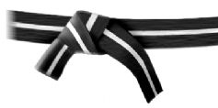
Shodan- Ho (Junior Black Belts – for ages 12 – 15)
*All Shodan requirements at an age-appropriate level

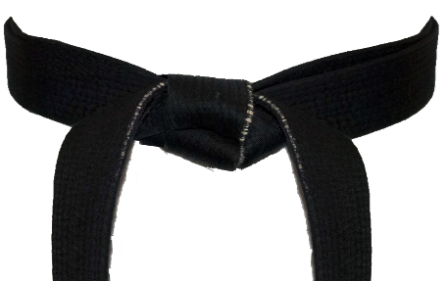
Shodan (First degree black belt – ages 16+)
Sanchin
Gekisai lchi
Gekisai Ni
Saifa
Shisochin
Seiunchin
Tenchi
Seiryu
Byakko
Tensho
Kobudo - Bo
Kobudo - Sai
Kobudo - Tonfa
Bunkai: Gekisai Sai lchi, Gekisai Sai Ni, Saifa, Shisochin, Seiunchin
Kumite: Endurance, Technique, Spirit
History of karate
Reading list requirements & Essay

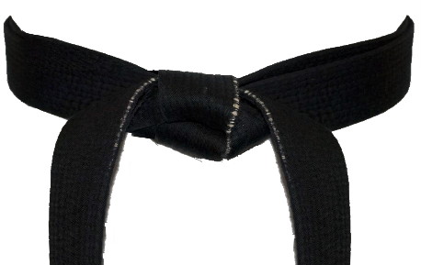
Nidan (Second degree black belt – ages 18+)
Sanchin- Tensho
Sanseiryu
Shujaku
Kobudo – Matsu Higa (1 weapon)
Tenshi – 2 person kata
Bunkai Concepts
Tai Chi Concepts (5 Elements Set) Left & Right side
Kumite Concepts
Conditioning/Endurance
History of Karate
Reading list requirements & Essay

Sandan (Third degree black belt)
Sanchin- Tensho
Seisan
Genbu
Seiryu – Byakko 2 person kata
Kobudo – Matsu Higa (2 weapons)

(Sandan Con’t.)

Tai Chi Concepts (13 postures)
History of Karate
Reading list requirements & Essay

Yondan (Fourth degree black belt)

Godan (Fifth degree black belt)

